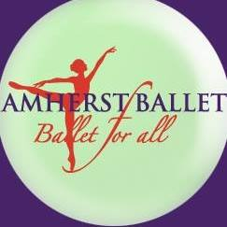

2019/2020 Dress Code

Girls:
Ballet
Pink Tights and pink ballet slippers
Leotard color
Pre-Primary&Primary: Light Pink
Level I: Lavender
Level II: Light blue
Level III: Purple
Level IV: Emerald/Forest Green
Intermediate: Royal blue/Navy
Advanced: Red/Burgundy
- Black leotards acceptable for all levels.
- No restrictions on sleeve style
Modern: T-shirts and Jazz pants/leggings
Hip Hop: Clean sneakers, Leggings or sweat pants (no shorts), comfortable top

Boys:
Ballet
Black ballet slippers, dance belt, black tights (suspenders optional), a white short sleeve shirt or white leotard
Modern: T-shirt and Jazz pants
Hip Hop: Clean sneakers, sweat pants (no shorts), comfortable top

