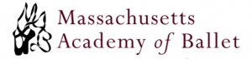
2020/2021

Required Logo Leotard: So Danca Patricia/Patti
Required Tights: BodyWrappers C45/A45 TPK
Required Shoe: Angelo Luzio 246A/C

Tots and Creative Movement – Celestial Blue
Pre-ballet – Black
Level 1 – Light Blue
Level 2 – Red
Level 3A and 3B – Green
Level 4 – Celestial Blue
Level 5 – Navy
(Level 3 to 5 may also purchase Black leotards in addition to, not instead of, the colors stated above.)

Boys: White T-shirt, black tights, black shoes, dance belt

