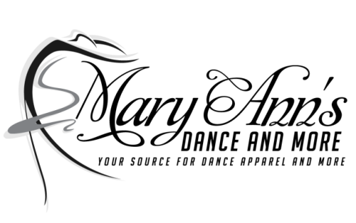
396 Main Street, Suite I
Easthampton, MA 01027
Phone: 413-282-0054/Text: 413-282-7871
E-mail: MaryAnn@MaryAnnsDanceandMore.com
Web: www.MaryAnnsDanceandMore.com

Updated 9/12/2020

Beginning June 9th, we will be opening with the following restrictions and safety protocols in place in accordance to the Massachusetts Re-opening Phase II Guidelines in place.
We will continue to offer curbside pickup, ship direct and limited “appointment only shopping,” for customers who are more comfortable shopping that way.

Social Distancing
- We are able to have 16 customers (including store staff) in store at one time
- We have put markers outside of the store to ensure 6 feet of distance for customers who are waiting outside to enter
- We have installed plexiglass barriers at checkout
- We have visually marked social distancing to encourage customers to remain 6 feet apart at check out
- We have at least 6 feet of physical distance between racks.
- We require face coverings for all customers, except where unsafe due to medical condition or disability
- We are unable to sell snacks as we have in the past
- Fitting rooms are now open
- We have contactless payment methods

Hygiene Protocols
- We will have alcohol-based hand sanitizers with at least 60% alcohol at entrances and throughout floor areas
- We have to prohibit the use of reusable bags; stores are permitted to use plastic or paper bags
- We will clean hard surface areas frequently and in between customers

Staffing and Operations
- We will have reduced hours to allow for on-going off-hour sanitation and cleaning
- We will continue to have deliveries made in the current designated area
- We will post notice to customers of important health information and relevant safety measures as outlined in the Commonwealth’s Mandatory Safety Standards for Workplace

Cleaning and Disinfecting
- We will conduct frequent cleaning and disinfection of site (at least daily and more frequently if feasible)
- We will keep cleaning logs that include date, time, and scope of cleaning
- We will conduct frequent disinfecting of heavy transit areas and high-touch surfaces (e.g., doorknobs, bathrooms, baskets, carts, staff break rooms)
- In event of a positive case, shut down site for a deep cleaning and disinfecting of the workplace in accordance with current CDC guidance

